Lindblad Master Equation
In a closed quantum system, a qubit evolves only according to the Schrödinger equation. The Hamiltonian contains all the information required to determine how the state of the qubit evolves with time.
However, this is an ideal quantum system where we assume that the qubit is completely isolated from its surroundings. In reality, the qubit constantly interacts with its environment, making it an open quantum system. These interactions introduce noise, which affects the evolution of the qubit. To model these effects, we use the Lindblad Master Equation.
The two main noise processes affecting a qubit are amplitude damping and pure dephasing.

Amplitude Damping
A qubit has two energy levels: the higher-energy excited state |1⟩ and the lower-energy ground state |0⟩. The excited state loses energy to the surrounding environment and relaxes to the ground state. Since the qubit is assumed to be in a cold environment, the ground state has very little chance of absorbing energy and transitioning back to |1⟩. Thus, the overall effect is a net relaxation of the qubit towards the ground state. This energy relaxation process is known as amplitude damping and is characterized by the relaxation time T₁.
The rate of amplitude damping is given by
γ₁ = 1 / T₁.

Pure Dephasing
Unlike amplitude damping, pure dephasing does not involve any exchange of energy with the environment. Instead, it affects only the relative phase of the quantum state.
The two basis states evolve as
|0⟩ → e^{−iE₀t/ħ} |0⟩,
|1⟩ → e^{−iE₁t/ħ} |1⟩.
Therefore, an arbitrary qubit state
|ψ(0)⟩ = α|0⟩ + β|1⟩
evolves as
|ψ(t)⟩ = e^{−iE₀t/ħ}( α|0⟩ + β e^{−i(E₁−E₀)t/ħ} |1⟩ ).
The overall phase has no physical significance, so only the relative phase
e^{−i(E₁−E₀)t/ħ} = e^{−iωt}
determines the quantum state.
Now due to interactions with the environment, this frequency ω keeps fluctuating randomly with time. As a result, every measurement accumulates a slightly different phase. When we average over many measurements, these random phases cancel each other out, causing the off-diagonal elements of the density matrix to decay while the populations remain unchanged. This process is called pure dephasing and is characterized by the dephasing time T_{φ},
γ_{φ} = 1 / T_{φ}.

Lindblad Master Equation
The time evolution of an open quantum system is given by
dρ/dt = −i[H, ρ] + Σ_{k} ( L_{k} ρ L†_{k} − ½ { L†_{k} L_{k}, ρ } ).
The first term represents the evolution of the qubit due to the Hamiltonian. It only causes the state of the qubit to rotate and does not introduce any decoherence. The second term represents the interaction of the qubit with the environment through the Lindblad jump operators.
For amplitude damping,
L = √γ₁ |0⟩⟨1|,
and for pure dephasing,
L = √(γ_{φ}/2) σ_{z}.
To understand the effect of each noise process separately, we first ignore the Hamiltonian term and consider only the Lindblad part of the equation.

Amplitude Damping
Ignoring the Hamiltonian term,
dρ/dt = LρL† − ½ ( L†Lρ + ρL†L ).
Substituting L = √γ₁ |0⟩⟨1|
gives
dρ/dt = γ₁ ×
ρ₁₁ | −ρ₀₁/2
−ρ₁₀/2 | −ρ₁₁
Comparing the corresponding matrix elements,
dρ₁₁/dt = −γ₁ρ₁₁,
dρ₀₀/dt = γ₁ρ₁₁,
dρ₀₁/dt = −(γ₁/2)ρ₀₁,
dρ₁₀/dt = −(γ₁/2)ρ₁₀.
Solving these equations gives
ρ₁₁(t) = ρ₁₁(0) e^{−γ₁t},
ρ₀₀(t) = 1 − ρ₁₁(0) e^{−γ₁t},
ρ₀₁(t) = ρ₀₁(0) e^{−γ₁t/2},
ρ₁₀(t) = ρ₁₀(0) e^{−γ₁t/2}.
From these equations, we can see that the excited-state population decreases exponentially while the ground-state population increases. The coherence also decays with time. Thus, amplitude damping causes both energy loss and a reduction in coherence.

Pure Dephasing
For pure dephasing,
L = √(γ_{φ}/2) σ_{z}.
Substituting this into the Lindblad equation gives
dρ/dt =
0 | −γ_{φ}ρ₀₁
−γ_{φ}ρ₁₀ | 0
Comparing the corresponding matrix elements,
dρ₀₀/dt = 0,
dρ₁₁/dt = 0,
dρ₀₁/dt = −γ_{φ}ρ₀₁,
dρ₁₀/dt = −γ_{φ}ρ₁₀.
The solutions are
ρ₀₀(t) = ρ₀₀(0),
ρ₁₁(t) = ρ₁₁(0),
ρ₀₁(t) = ρ₀₁(0) e^{−γᵨt},
ρ₁₀(t) = ρ₁₀(0) e^{−γᵨt}.
Here, the populations remain unchanged since there is no energy exchange with the environment. However, the coherence decays exponentially, which is the signature of pure dephasing.

Amplitude Damping and Pure Dephasing Together
In reality, both noise processes act simultaneously. Therefore, both jump operators are included in the Lindblad equation.
The resulting evolution is
dρ/dt =
γ₁ρ₁₁ | −(γ₁/2 + γ_{φ})ρ₀₁
−(γ₁/2 + γ_{φ})ρ₁₀ | −γ₁ρ₁₁
Comparing the corresponding matrix elements,
dρ₁₁/dt = −γ₁ρ₁₁,
dρ₀₀/dt = γ₁ρ₁₁,
dρ₀₁/dt = −(γ₁/2 + γ_{φ})ρ₀₁,
dρ₁₀/dt = −(γ₁/2 + γ_{φ})ρ₁₀.
The corresponding solutions are
ρ₁₁(t) = ρ₁₁(0) e^{−γ₁t},
ρ₀₀(t) = 1 − ρ₁₁(0) e^{−γ₁t},
ρ₀₁(t) = ρ₀₁(0) e^{−(γ₁/2 + γφ)t},
ρ₁₀(t) = ρ₁₀(0) e^{−(γ₁/2 + γφ)t}.
The coherence decay rate is therefore
γ₂ = γ₁/2 + γ_{φ}.
Since γ₁ = 1/T₁, γ_{φ} = 1/T_{φ}, γ₂ = 1/T₂,
we obtain
1/T₂ = 1/(2T₁) + 1/T_{φ}.
This relation shows that the coherence time of a qubit depends on both energy relaxation and pure dephasing. Therefore, both processes must be minimized to improve the performance of a quantum computer.

Explanation of My Code-

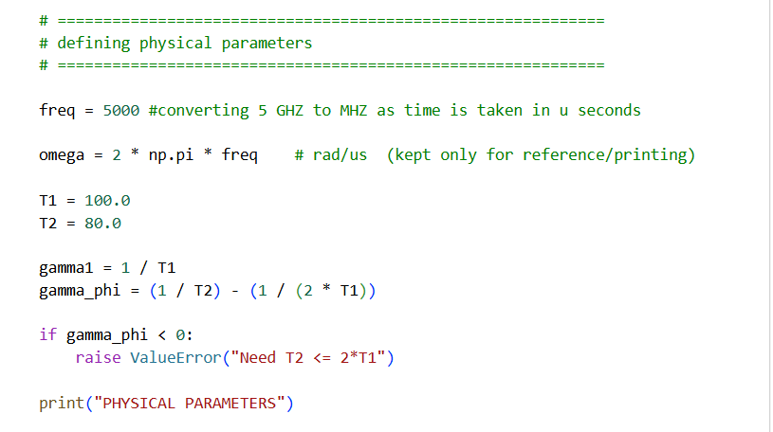First I define the parameters. I convert frequency to MHz since the unit of time I use throughout is microseconds. Then I define omega, T1, and T_phi from the properties of the qubit mentioned in the problem statement. 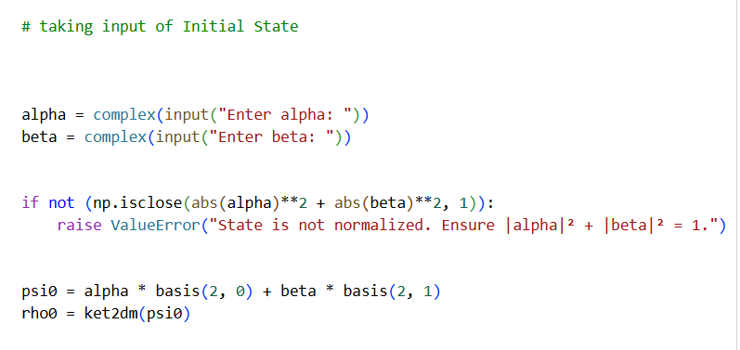
Then I take input of the initial quantum state from the user and check the normalization condition.
I use the basis and ket2dm functions from qutip to define the initial qubit state, first as a state vector and then as a density matrix. 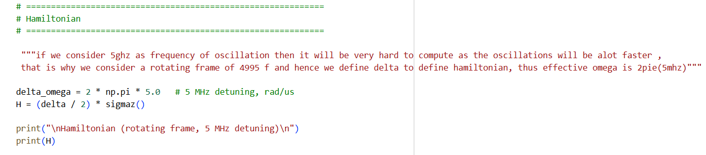
If I keep f = 5GHz, the rotations will be too fast and it'll be hard to compute the density matrices at time t, so instead I define f of a rotating frame. Then I take the difference in omega to get delta, and using delta/2 * Z I get the Hamiltonian. 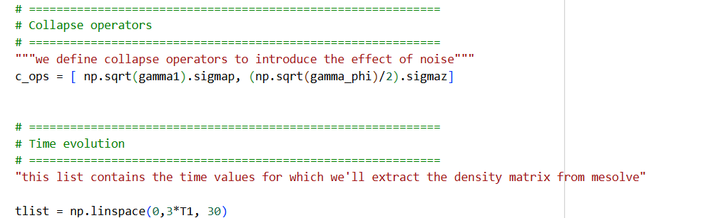
I define collapse operators, c_ops, as a list which has root(gamma1) * ket0 bra1, and root(gamma_phi/2) * Z.
I define t_list, which contains all the time instances for which I'll ask mesolve to extract the result. 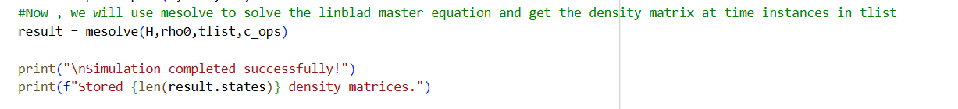
Now I use mesolve to solve the Lindblad master equation and get the density matrix at the time instances in tlist. I pass in H, initial state, t_list, and c_ops.
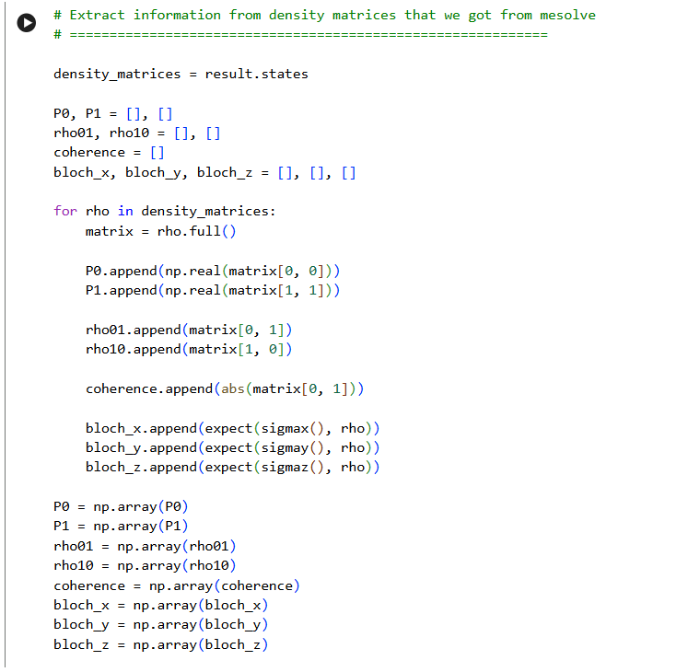result is an object that has our density matrices at t (from t_list) stored in it. Now, to extract info, I define a list for each of P0, P1, etc, then loop over each density matrix in result.states and extract the info from it and append it to the list. Once the list is formed, I convert it into np arrays.
Now I print the density matrices at some important time instances (0, T2, T1, 2*T1) just to see how the state looks at those points, and I also print the trace at each of these to make sure it stays 1.
Then I plot P0 and P1 with respect to time to see what happens to the population of the ground and excited states under the effect of noise. I also mark T1 on the plot with a vertical dashed line to show where the population is expected to have decayed.
Next I plot the real coherence, |rho01|, with respect to time to see how it decreases with time, and I mark T2 on the plot since that's the characteristic decay time for coherence.
Then I plot the real and imaginary parts of rho01 against each other to see the coherence rotate and shrink inward over time — this basically shows both the dephasing and the rotation from the Hamiltonian happening together. I mark the initial point in red so it's clear where the state starts from.
I also plot the Bloch vector using qutip's Bloch class, by adding the bloch_x, bloch_y, bloch_z points I calculated earlier, along with a vector for the initial state, so I can visualize the trajectory of the qubit state on the Bloch sphere as it decays.
After that, I check the steady state. Since I'm only including amplitude damping and dephasing (no thermal excitation), I expect the qubit to end up in the ground state at long times. So I take the final density matrix from my simulation and compare it to the expected ground state density matrix using the trace norm of their difference, just to confirm the qubit has relaxed to |0⟩.
Finally, I check trace preservation by calculating the trace error, i.e. how far the trace of each density matrix is from 1, across all the time steps, and print the maximum of these errors to confirm my simulation is valid (since the trace of a density matrix must always be 1).

